EX NO 12 : Identification of C Keywords Using LEX

Aim:
To write a LEX program to identify and print all C keywords present in a given C source program.
Algorithm:
- Start the program.
- Define patterns for C keywords such as int, if, and return.
- Read the C source program as input.
- Identify and print each keyword found.
- Ignore identifiers, constants, spaces, and special symbols.
- Stop the program.

Program:

%{
#include <stdio.h>
%}

%%
"int"|"if"|"return" { printf("Keyword: %s\n", yytext); }
[a-zA-Z_][a-zA-Z0-9_]* ;
[ \t\n]+ ;
. ;
%%

int main()
{
yylex();
return 0;
}

int yywrap()
{
return 1;
}
}}Sample input:
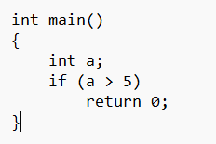
Sample output:
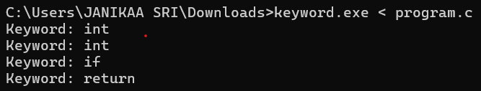

Result:
The LEX program was executed successfully and identified and printed the C keywords present in the given source program.

